Q: What is the certification time for CPR?
A: The certification is valid for two years through the American Heart program and 1 year through the American Red Cross program.
Q: Are coaches that are eligible in other states automatically eligible in our state?
A: No, the qualifications would have to be reviewed first to ensure they meet the requirements in our state.
Q: Are certified teachers automatically eligible?
A: They must meet the eligibility requirements listed in the by-law.

Q: What is the best estimate of the cost to a school to implement this program?
A: It could cost $100.00 per coach depending on the resources available in the community.

Q: Will coaches at any level be grandfathered?
A: No.

Q: How will coaches have access to rules review meetings?
A: Coaches may attend meetings sponsored by the various Coaches Associations, meetings scheduled by the various sports officials organizations, or invite officials to the school to sponsor a rules review –(only in certain sports) (recommended yearly, required every three years)

NHIAA Coaches
Education Committee:
Jason Strniste, Bishop Guertin, Chair
Mike Atkins, Keene
Rick Forge, Moultonborough
Todd Kress, Pelham
Craig Kozens, Laconia
Andy Lathrop, Oyster River
Tim Powers, Pinkerton

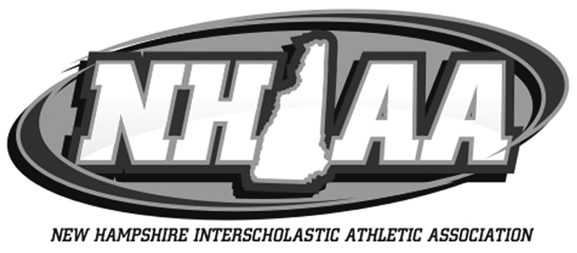

OFFICIAL
INTERPRETATION
OF
BY-LAW ARTICLE I:
POLICY
SECTION 32:
COACHES ELIGIBILITY

For:
Principals, Athletic Directors,
Coaches, Officials & Parents

2023-24

BY-LAW ARTICLE I: POLICY
SECTION 32:
COACHES ELIGIBILITY
- A current certification in First Aid.
- A current certification in CPR with AED Certification
- Completed a Coaching Principles Course approved by the Coaches Education Committee. Approved list is located on the NHIAA website.
- Completed the NFHS Concussion Course (free of charge). This course MUST be taken prior to any coaching and a new certificate on file the start of every even numbered school year (i.e. 2020-21; 2022-23).
- Completed the NFHS Heat Illness Course (free of charge). This course MUST be taken prior to any coaching, and is a one and done course.
- All first year head varsity coaches must attend a rules review (live/zoom) within one year of hire hosted by the sport official’s association. All head varsity coaches in their second year or beyond are required to complete a yearly on-line rules update or attend a rules review given by their sports specific rules organization.
- All first year gymnastics coaches are required to attend a live rules review PRIOR to coaching.
- In order for a team to perform any stunting/aerial tumbling, they must be supervised by a coach who has taken the USA Cheer Safety and Risk Management Course. In the absence of someone who is USA Cheer Safety and Risk Management Course certifed, the team must be ground bound. (CM 11.2017)
NOTE:
- New coaches have one (1) year from date of hire to complete (A; C and F). All other items above are required prior to coaching.

- *B: Requires that someone certified be on the field/court until the coach completes the requirements.
- The above is recommended for volunteer coaches.
- Coaches hired after June 2004 who became eligible through the sport specific clinic/workshop will be required to take the NFHS Coaching Principles course or comparable program approved by the Coaches Education Committee.
- It is recommended coaches continue their professional development through additional education clinics and opportunities listed on the NHIAA website.
- List of approved courses can be found on NHIAA Website
- The NFHS offers additional certifications, including Accredited Interscholastic Coach and Certified Interscholastic Coach. Go to NFHSLearn.com for more information. (CM 5.2018)
- The NHIAA is authorized by the Coaches Education Committee to evaluate the professional credentials of trained medical personnel on an individual basis (CM 11.2018)
- Enrollment of Coaches - All coaches who coach NHIAA contests at all levels must be enrolled with the NHIAA. There is a $25.00 annual enrollment fee.

Questions & Answers
In order to be eligible to coach in a NHIAA member school the person must have (or be in the presence of someone with*) (CM 5.2016):

Q: What is the rationale for the by-law?
A: This will increase education and awareness for the coaches and will provide a foundation for those who do not have a lot of training in the area. It will create a safer environment for the students and coaches. The quality of sport education will improve for the students.

Q: What is the penalty if a coach is not eligible yet coaches in a game/match/event/meet, etc.
A: All the games will be forfeited in the same mode as using an ineligible contestant. By-Law Article II, Eligibility; Sect. 20.
Q: Will coaches at all levels be required to go through the training in order to be eligible?
A: Yes at the sub-varsity and varsity levels.

Q: What is the policy regarding volunteer coaches?
A: A volunteer coach is anyone who is consistently under the direct supervision of the varsity or other sub-varsity coach and is never left alone with the student athletes. Volunteers are highly encouraged to go through the training.
Q: What is the time line for the training after a new coach is hired?
A: One year from date of hire.
Q: What will be the role of the NHIAA in this process?
A: The NHIAA will supply updated resource guides, supply information on the website of available clinics, and will have a subcommittee to review curriculums of other courses to determine equivalency.
Q: Who are the contacts to provide CPR?
A: Local health personnel, school nurses, local Fire Department, NH Heart Association, American Red Cross.

