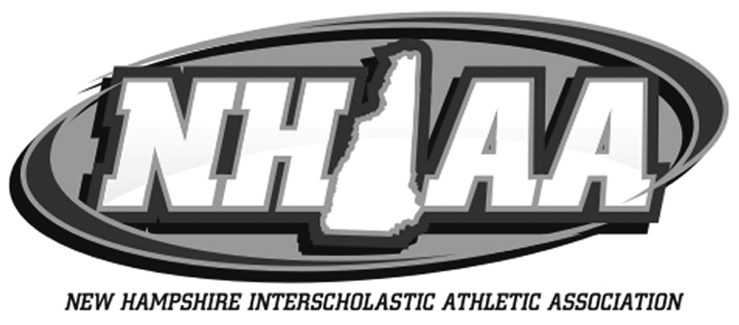
If you would like a copy of this nomination form in Microsoft Word for easy typing and formatting, please send a request to info@nhiaa.org

251 CLINTON STREET
CONCORD, NEW HAMPSHIRE 03301-8432
OFFICE # (603) 228-8671 FAX # (603) 225-7978

TO: Principals & Athletic Directors
NHIAA Member Schools

FROM: Jeffrey T. Collins, Executive Director

SUBJECT: Walter A. Smith Special Recognition Award

The NHIAA Council has developed a program to honor the memory of Walter A. Smith, Executive Director, NHIAA, 1958-1984, by awarding plaques to one female and one male in his name.

The program was designed to recognize individuals who have overcome special circumstances and contributed significantly and positively to the NHIAA as a player, manager, or fan.

Attached, please find a copy of the criteria and nomination form. If you wish to submit more than one nomination, please feel free to duplicate the application provided.

JTC:dsp

NEW HAMPSHIRE INTERSCHOLASTIC ATHLETIC ASSOCIATION
251 CLINTON STREET
CONCORD, NEW HAMPSHIRE 03301-8432
OFFICE # (603) 228-8671 FAX # (603) 225-7978

IN MEMORY OF WALTER A. SMITH
EXECUTIVE DIRECTOR NHIAA
1958-1984

I. CRITERIA

The NHIAA Council will recognize annually one male and female student from NHIAA schools through the awarding of Walter A. Smith Special Recognition Award Plaque. These students will be selected from a nominated pool of students (State-wide) who:

A. Have overcome special circumstances.

B. Contributed significantly and positively to NHIAA athletics as a player, manager, or fan.

II. NOMINATION PROCESS

A. The person wishing to nominate an individual will fill out a nomination form and enclose a statement explaining the special circumstances the individual overcame, and how they have contributed significantly to NHIAA athletics.

B. The nomination must be received in the NHIAA Office,
251 Clinton Street, Concord, NH 03301, no later than April 15 of each year.

III. NOMINATION REVIEW

The NHIAA Awards Committee will review the nomination forms and statements received.

IV. NOTIFICATION/ANNOUNCEMENT OF AWARDS

The Executive Director shall contact the finalists and arrange the presentation of the award.

NOMINATION FORM

WALTER A. SMITH SPECIAL RECOGNITION AWARD

NOMINEE'S NAME:___________________________________

HIGH SCHOOL:______________ _

ADDRESS: _________________________________________________________________

CITY:_____________________________STATE:_______________ ZIP CODE:__________

TELEPHONE:________________GRADE:______________MALE____FEMALE______

PARENT/GUARDIAN NAMES:

FATHER - ____________________________________________

MOTHER- ____________________________________________

NOMINATOR'S NAME:_____________________________________________________

ADDRESS: ________________________________________________________________

CITY:_____________________________STATE:_______________ ZIP CODE:__________

PHONE NUMBER:__________________________________

**Please attach a typewritten statement, which clearly states your reasons for nominating this individual. Please explain the special circumstance he/she has overcome and the significant contributions he/she has made to NHIAA athletics as a player, manager, or fan.

Signature of Nominator _____________________________________________________________

(All applications must be received by April 15 of each year or earlier.)

